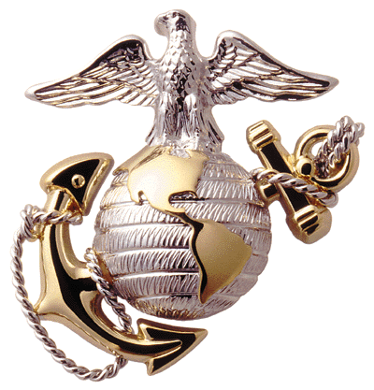

***Public Service Announcement Samples***

**PUBLIC SERVICE ANNOUNCEMENT**

2d Marine Division Band **Contact:** Corporal Sean Healey

ATTN: Public Affairs Office **Phone:** (910) 450-9511

PSC Box 20088 **Fax:** (910) 451-2937

Camp Lejeune, NC 28542

*FOR IMMEDIATE RELEASE:*

**2D MARINE DIVISION BAND**

*CAMP LEJEUNE, NORTH CAROLINA*



*15-Second Spot (Air Time)*

**The 2d Marine Division Band, on tour from Camp Lejeune, North Carolina, will be in the (***city/town***) area on (***day/date***) at (***location***). This patriotic program, sponsored by (sponsor), is free and opens to the public, and will begin at (***time***).**

**PUBLIC SERVICE ANNOUNCEMENT**

2d Marine Division Band **Contact:** Corporal Sean Healey

ATTN: Public Affairs Office **Phone:** (910) 450-9511

PSC Box 20088 **Fax:** (910) 451-2937

Camp Lejeune, NC 28542

*FOR IMMEDIATE RELEASE:*

**2D MARINE DIVISION BAND**

*CAMP LEJEUNE, NORTH CAROLINA*



*30-Second Spot (Air Time)*

**From Camp Lejeune, North Carolina, the 2d Marine Division Band will present a very special (***afternoon/evening***) of musical entertainment in the (***city/town***) area on (***date***). With an authorized strength of one officer and fifty enlisted Marines, the ensemble promises an exciting, versatile concert that the entire family will enjoy. The program will be selected from the Band’s extensive repertoire, to include familiar marches, traditional classics, patriotic favorites, jazz, country, and popular contemporary music. This concert is free and open to the public. The performance will take place at (***location***) on (***day/date***) and is set to begin at (***time***). For more information, contact (***sponsor***).**

**PUBLIC SERVICE ANNOUNCEMENT**

2dMarine Division Band **Contact:** Corporal Sean Healey

ATTN: Public Affairs Office **Phone:** (910) 450-9511

PSC Box 20088 **Fax:** (910) 451-2937

Camp Lejeune, NC 28542

*FOR IMMEDIATE RELEASE:*

 **2D MARINE DIVISION BAND**

*CAMP LEJEUNE, NORTH CAROLINA*



*45-Second Spot (Air Time)*

**The 2d Marine Division Band, currently on tour from Camp Lejeune, North Carolina, will present a memorable (***afternoon/evening***) of musical entertainment in the (***city/town***) area on (***date***).**

**Spanning the continental United States, the musicians of this Marine Corps Band entertain audiences at more than 250 performances each year. With an authorized strength of one officer and fifty enlisted Marines, the band travels the country carrying on a long-standing tradition of excellence and service to both Corps and Country.**

**The Band promises an exciting program that the entire family is sure to enjoy. Performance numbers will be selected from familiar marches, traditional classics, patriotic favorites, big band sounds, jazz, country, and Top 40 hits.**

**This concert, sponsored by (***sponsor***), is free and open to the public. The performance will take place on (***day/date***) at (***location***) and is set to begin at (***time***).**